Toolbox Manual

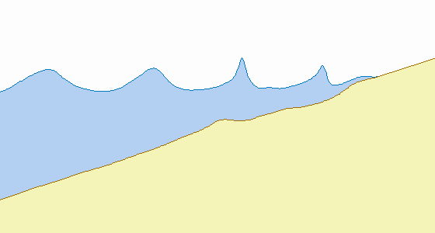

A.F. Velegrakis and I. Monioudi
Department of Marine Sciences
School of Environment
University of Aegean

June 2014

 UNEP(DEPI)MED WG 396/2 Tunis June 2014

Contents
1 Empirical orthogonal function analysis GUI Manual 2
1.1 Introduction 2
1.2 How to use the program 2
1.3 Output files of this platform 5
2 Wind Data Analysis GUI Manual 7
2.1 Introduction 7
2.1.1 Wind direction 7
2.1 2 Wind velocity (or intensity) 8
2.1.3 Windrose 9
2.2 How to use the program 9
3 Wave Estimation GUI Manual 12
3.1 Introduction 12
3.2 Wave estimation from wind data 13
3.3 How to use the program 13
4 Beach Retreat Estimator 2-Static/Analytical models GUI Manual 16
4.1 Introduction 16
4.2 How to use the program 16
4.3 Output files of the platforms 19
5 Beach Retreat Estimator 3-Dynamic models GUI Manual 21
5.1 Introduction 21
5.2 How to use the program 21
5.3 Output files 24
References 28

1 Empirical orthogonal function analysis GUI Manual
1.1 Introduction
Beach profile variability is analysed using Empirical Orthogonal Functions-EOFs (Komar, 1998). Conceptually, the objective of the analysis is to separate the temporal and spatial dependence of the data so that the information can be represented as a combination of corresponding functions of time and space. It involves the generation of sets of eigenfunctions that can translate the original information (i.e. the time series of beach profiles) in terms of its principal components and determine the major (dominant) modes of the beach morphological change; this can not only simplify the study of the main trends, but also provide the dominant beach profile for the observation period (e.g. Winant et al., 1975; Aubrey, 1979).
The EOF analysis of beach profile time series involves the determination of the dominant spatial and temporal eigenfunctions which correspond to the largest eigenvalues; each eigenvalue represents a certain fraction of data variability. The largest spatial eigenfunction (e1) which is related to the highest eigenvalue λ1, is considered as the ‘mean beach function’ which represents the ‘mean’ beach profile during the period of observations. The remainder of the high-order spatial (space) eigenfunctions (i.e. those with high eigenvalues λ) may represent other beach profile trends, such as the dominant location of significant beach morphological features (e.g. berms and submarine bars -the ‘bar-berm function’ e2 or the low-tide terrace-the ‘terrace function’ e3. The largest temporal (time) eigenfunction (c1), which is also related to the highest eigenvalue λ1, is considered to provide information on temporal beach erosion and accretion trends, whereas the second high-order temporal eigenfunction c2 (related to the second higher eigenvalue λ2) may represent seasonal variations on the onshore-offshore movement of beach sediments.
For more details on the theory and procedures of the method, see the accompanying material (Formation Zones d’Erosion).

1.2 How to use the program
The GUI estimates spatial and temporal modes of beach profile time series using EOFs. Following the installation of the MCR, the platform can be operated by simply double-clicking on the EOF.exe; then the screen shown in Fig. 1.1 appears (it may take some time to open).
In the panel named ‘Insert time series of profile surveys’ (Fig. 1.1), the user can browse the directory that contains the files of profile time series using the button ‘Browse…’. Then the path of the directory appears in the edit box ‘Enter the path of time series directory’. This directory must contain the following files:
- Files with the beach profile time series. Each (.txt) file contains the cross-shore distance x (1st column) and the elevation z (2nd column). Filenames include a profile position counter and a survey counter (Name_p001_t001, Name_p002_t001, .., Name_pi_t001, ..., Name_pi_tj, where I is the number of profile positions and j the number of the surveys (001≤ I ≤ 999, 012 ≤ j ≤ 999).
- a (.txt) file with the dates of surveys, e.g. 1st line 10/01/2012, 2nd line 20/04/2012, .....
- a 1-column (.txt) file with the y (longshore) locations of the profile lines (it is needed for the 3-D plot and the second EOF estimation).

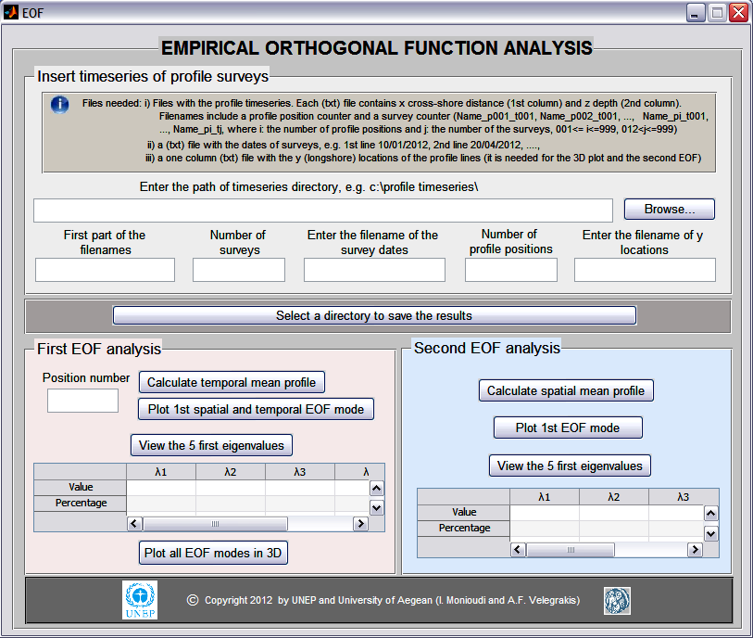

Fig. 1.1 The EOF GUI.

Users should also enter the first part of the filenames (e.g. Er for the filenames Er_p001_t001,…..Er_pi_tj of the example), the number of surveys, the name of the .txt file that contains the survey dates, the number of profile positions and the name of the txt file that contains the y (long-shore) co ordinations of the profile positions (Fig. 1.2).

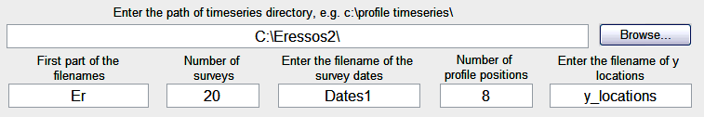
Fig. 1.2 Examples of input information.

Users can select the directory where the output files are saved by pushing the button ‘Select a directory to save the results’.
Once all parameters are determined, users can enter a position number and estimate for this position the temporal mean profile, plot the first spatial and temporal EOF modes (Fig. 1.3) and view the 5 highest eigenvalues (λ1, λ2,…λ5) by pushing the buttons ‘Calculate temporal mean profile’, ‘Plot 1st spatial and temporal EOF mode’ and ‘View the 5 first eigenvalues’ (inside the panel ‘First EOF analysis’), respectively.
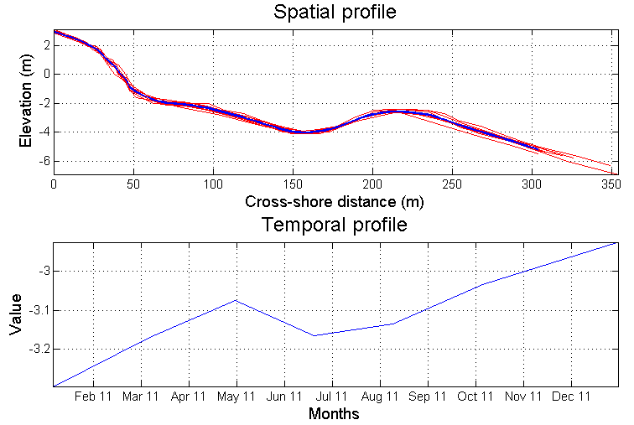
Fig. 1.3. Example of spatial and temporal EOF mode plots

By pushing the button ‘View the 5 first eigenvalues’ the 5 highest eigenvalues and the fraction (percentage) of variability they contain appear in the table of Fig. 1.4. If the mean (from EOF) profiles for all positions are estimated, users can plot them together in a 3-D format (Figure 1.5) by pushing the button ‘Plot all EOF modes in 3-D’

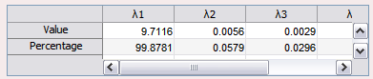
Fig. 1.4 Example of 5 first eigenvalues.

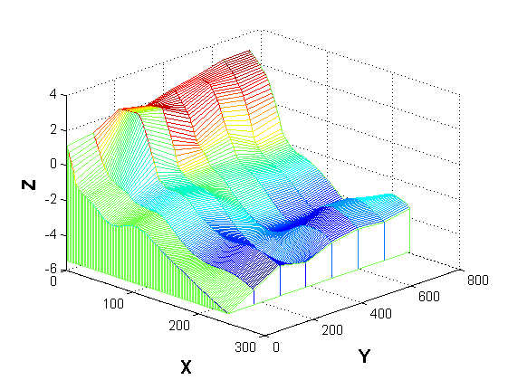
Fig. 1.5 Example of first spatial EOF modes (from the first EOF analysis) 3-D plot.

Users can apply a second EOF analysis to the (EOF) mean profiles and determine a spatial mean profile representing the whole beach from which profiles from different positions have been measured, by pushing the button ‘Calculate spatial mean profile’ inside the panel ‘Second EOF analysis’. Then they can plot the first EOF mode (Fig. 1.6) and view the 5 first eigenvalues by pushing the buttons ‘Plot 1st EOF mode’ and ‘View the 5 first eigenvalues’ respectively.

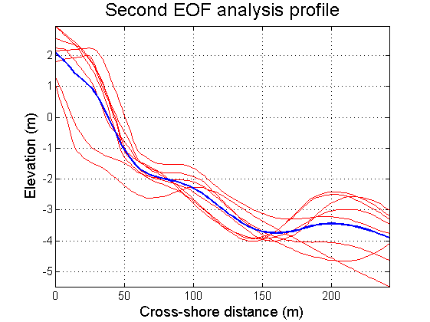

Fig. 1.6 Example of first spatial EOF mode (from the second EOF analysis) plot.

1.3 The output files of this platform

path.txt: contains the path of the imported files.
mean_profile1, ... , mean_profilen, where n is the number of positions: contains the ‘mean’ profile (1st column, cross-shore distance in meters, 2nd column, elevation in meters) for each position.
spatial_mode.txt: contains the temporal ‘mean’ profiles (elevation in meters) viz. the first spatial EOF mode for each position. Each column corresponds to a different position.
crosshore_distance.txt: contains the cross-shore distance (in meters) that corresponds to the elevation values written in spatial mode file. Each column corresponds to a different position.
spatial_eigenvalues.txt: contains the 5 first eigenvalues for each position. Each row corresponds to a different position and each column to a different eigenvalue.
perc_variability.txt: contains the percentage of variability in the 5 first eigenvalues. Each row corresponds to a different position and each column to a different eigenvalue.
temporal_mode.txt: contains the first temporal EOF mode for each position. Each column corresponds to a different position and each row corresponds to a different date.
interpolated_1rst_EOF_profiles.txt: contains the interpolated ‘mean’ profiles (elevation in meters). Each row corresponds to a different position.
spatial_mode.txt: contains the ‘spatial mean’ profile (from the second EOF analysis) viz. the first spatial EOF mode. The first column is the cross-shore distance (in meters) and the second column is the elevation (in meters).
Position1.tif......Positioni.tif where i: the number of profile positions: the figures of first spatial and temporal EOF mode (from the first EOF analysis). These files are created only if users have pressed the button ‘Plot 1st spatial and temporal EOF mode’.

2 Wind Data Analysis GUI Manual
2.1 Introduction
2.1.1 Wind direction
Wind is air in motion with respect to the earth’s surface. The major characteristics of the wind are the direction, from which it originates and its velocity/speed.

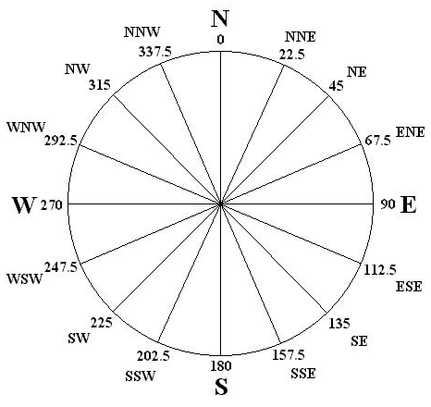
Fig. 2.1 8 main and 8 secondary directions.

It is important to know how wind direction is recorded and reported. Wind direction is the compass direction from which the wind blows. For example, a northerly wind blows from the north to the south. The wind direction is expressed in degrees (0° to 360°) starting from the North and progressing clockwise (the direction 0° is the same with the direction 360°). 8 main and 8 secondary directions can be recorded as depicted in Fig. 2.1 and Table 2.1.

Table 2.1. The 8 main directions and corresponding sectors.
Wind | Main direction | Direction-sector
North | 0˚ | 338-23˚
Northeast | 45˚ | 23-68˚
East | 90˚ | 68-113˚
Southeast | 135˚ | 113-158˚
South | 180˚ | 158-203˚
Southwest | 225˚ | 203-248˚
West | 270˚ | 248-293˚
Northwest | 315˚ | 293-338˚

2.1 2 Wind velocity (or intensity)
Wind velocity is the distance that an air mass covers in the time unit and is controlled by the temperature of atmospheric layers. Wind velocity at the height of 10 m above sea level has been defined as the representative velocity. Therefore, if measurements are recorded at a different height wind velocities must be converted from the height of actual measurement to values at a height of 10 m above sea level, using the following equation:
$$U_{\text{10}}=U_{Z}({\text{10}}/z)^{1/7}$$ | [2-1]
where U_{z} is the wind velocity at the height of the measurement z and U₁₀ is the wind velocity at the height of 10 m.
There are several units of measurements such as: meters per second (m/sec), kilometers per hour (km/h), miles per hour (miles/h) and knots (knots = 1,852 m/h). Their correlation is:
1 m/s = 3.6 km/h = 1.944 knots = 2.237 miles/hour.
Historically, the Beaufort wind force scale provides an empirical description of wind speed based on observed sea conditions. The Beaufort scale was based on the equation:
$$U_{\text{10}}=0\text{.}\text{836}Β^{3/2}$$ | [2-2]
where B is Beaufort scale value and U₁₀ the wind speed (in m/s) at a height of 10 m.

Table 2.1 Correlation between Beaufort scale and wind velocity according with the Greek National Meteorological Service.
Wind intensities in Beaufort |  | Wind velocity
B | Wind situation | m/s | km/h | knots | miles/h
0 | Calm | 0-0.2 | < 1 | < 1 | <1
1 | Light air | 0.3-1.5 | 1-5 | 1-3 | 1-3
2 | Light breeze | 1.6-3.3 | 6-11 | 4-6 | 4-7
3 | Gentle breeze | 3.4-5.4 | 12-19 | 7-10 | 8-11
4 | Moderate breeze | 5.5-7.9 | 20-28 | 11-16 | 13-18
5 | Fresh breeze | 8.0-10.7 | 29-38 | 17-21 | 19-24
6 | Strong breeze | 10.8-13.8 | 39-49 | 22-27 | 25-31
7 | Moderate gale | 13.9-17.1 | 50-61 | 28-33 | 32-38
8 | Fresh gale | 17.2-20.7 | 62-74 | 34-40 | 39-46
9 | Strong gale | 20.8-24.4 | 75-88 | 41-47 | 47-54
10 | Whole gale | 24.5-28.4 | 89-102 | 48-55 | 55-63
11 | Storm | 28.5-32.6 | 103-117 | 56-63 | 64-74
>=12 | Hurricane | >= 32.7 | >= 118 | >= 64 | >=75

2.1.3 Windrose
A wind rose is a graphic tool used to give a succinct view of how wind speed and direction are typically distributed at a particular location. Presented in a polar coordinate grid, the wind rose shows the frequency of winds blowing from particular directions. The length of each spoke (beam) around the circle is related to the frequency that the wind blows from a particular direction per time unit. Each concentric circle represents a different frequency, emanating from zero at the center to increasing frequencies at the outer circles.
A wind rose plot (Fig. 2.2) may contain additional information, in that each spoke is broken down into color-coded bands showing wind speed ranges. Wind roses typically use 8 or 16 cardinal directions, such as north (N), NNE, NE, etc., although they may also be subdivided into as many as 32 directions.
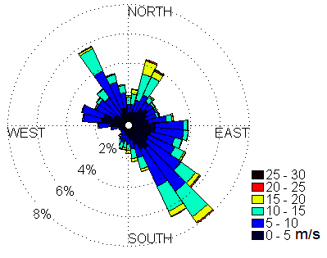

Fig. 2.2 Windrose of wind data from the meteorological station at the University Hill, University of Aegean .

Wind information consists of wind records every half an hour or every hour and includes the date and time of the records, the wind velocity and the wind direction. Analysis of the wind data involves:
- Conversion of the velocity units in m/s (if measurements are made in a different unit system).
- Reduction of the velocity from the height of measurements to the height of 10 m above sea level (U₁₀).
- Estimation for each of the 8 main direction-sectors and for each Beaufort number, of the wind frequency, mean wind velocity and mean wind duration

2.2 How to use the program
The GUI is operated through the exe file Wind_analysis. Following the installation of the MCR, the platform runs by double-clicking on the Wind_analysis.exe. Then the following screen appears (it might take some time to open):

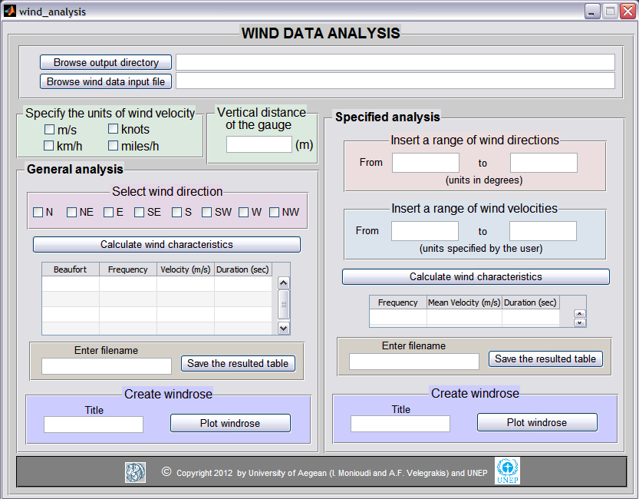
Fig. 2.3 The Wind_analysis GUI.

First, users should browse a .txt file that includes the wind velocity and direction measurements. The txt file should have the format shown in Fig. 2.4 (1st column is the day of the measurement, 2nd the month, 3rd the year, 4th the hour, 5th the minutes, 6th the seconds, 7th the wind velocity and 8th the wind direction). Users should also specify the wind velocity units through the panel "Specify the units of wind velocity" and the height of the measurement gauge above the sea level through the panel "Vertical distance of the gauge" (Fig. 2.3).

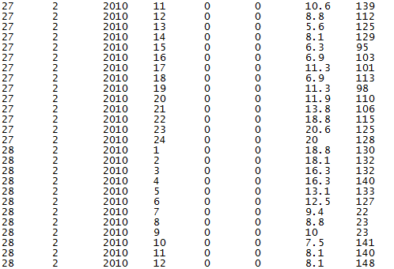
Fig. 2.4 An example of an input txt file.

In the panel "General analysis" users can select one of the 8 main direction-sectors and calculate the wind characteristics (by pushing the button "Calculate wind characteristics") i.e. the wind frequency, mean wind velocity and mean wind duration for each Beaufort scale number. The results are shown in the table below the button "Calculate wind characteristics" (Fig. 2.3). Users can save the results table by giving a filename in the edit box "Enter filename" and by pushing the button "Save the resulted table" (Fig. 2. 3). Users can also plot the windrose for the selected direction-sector using the button "Plot windrose" inside the panel "Create windrose" (Fig. 2.3). They also have the option to give a title to the windrose by entering the desired title in the edit box "Title" before using the button "Plot windrose".
A specified analysis option is also provided. Users can give a specific range of wind directions (in the panel "Insert a range of wind directions") and a specific range of wind velocities (in the panel "Insert a range of wind velocities") and calculate the wind frequency, mean wind velocity and mean wind duration by using the button "Calculate wind characteristics" in the panel "Specified analysis". The results are shown in a table (Fig. 2.3). Users can save the result table by giving a filename in the edit box "Enter filename" and by pushing the button "Save the resulted table" (Fig. 2.3). Users can also plot the windrose for the specified range of wind directions using the button "Plot windrose" inside the panel "Create windrose" (inside the panel "Specified analysis") (Fig. 2.3). They have the option to give a title to the windrose by entering the desired title in the edit box "Title" before pushing the button "Plot windrose".

3 Wave Estimation GUI Manual
3.1 Introduction
In the open sea, wind-induced waves are generated in stages following the wind generation (Komar, 1998): (i) formation of capillary waves (with period Τ < 1 sec, H about 0.01-0.02 m); (ii) generation of larger waves (in terms of wavelength L, height H and period T); and (iii) transfer of energy from the shorter to longer waves. It follows that wave conditions at the generation point are polychromatic, with many different, in terms of length height and period, co-existing waves(‘sea’). As these waves travel away from the generation point are ‘filtered’; long waves are both faster and less prone to dissipation than shorter waves and, thus, in the case of adequate wind energy transfer and distance to the shoreline, the original polychromatic sea will be gradually become a much more monochromatic swell.
Wind wave characteristics depend on the wind speed. In the estimation of the wind wave characteristics from wind data, the controlled wind speed U_{Α} is used; this is estimated from the wind speed at 10 m height above the sea surface U₁₀ through expression:
$$U_{A}=0\text{.}\text{71}(U_{\text{10}})^{1\text{.}\text{23}}$$ | [3-1]
The wind- sea surface energy transfer increases with the time of wind flow above the sea surface i.e. wind duration (t_{D}). Wind wave development also depends on the fetch (F), i.e. the maximum distance between two obstructions (e.g. coasts. islands) along which the wind can flow unhindered. When the fetch length is too short, there is no wind over a sufficient distance over which the full ranges of wave periods and heights are generated.The effective fetch of a location is estimated within a sector with a range ±45° relatively to the major direction, using the following expression (e.g. Koutitas, 1994):

$F_{\text{eff}}=\frac{\sum_{i}{F_{i}⋅{\left(\text{cos}a_{i}\right)}^{2}}}{\sum_{i}{\text{cos}a_{i}}}$ | [3-2]
where i describes the radius direction even 5° on either side of the wind direction, F_{i} is the linear fetch of direction i and α_{i} is the angle of radius i with the wind direction. Lengths of these linear fetches can be estimated graphically from offline and and/or online charts (or more details see the accompanying document Formation Zones d’ Erosion).
Wave condition can be differentiated into:
- Fully Developed Sea (FDS),which is supplied with the full energy of a wind of particular speed; this condition does not depend any more on the wind duration t_{D} or the fetch F_{eff}, with the wave parameters controlled only by the wind speed (U_{A}).
- Fetch-Limited Sea development (FLDS), which is characterised by a fetch F that is shorter than that required for the transfer of the maximum energy from a particular wind speed speed U_{A}; this condition does not depend on the wind duration t_{D}, with the wave parameters controlled by the wind speed U_{A} and the effective fetch F_{eff}.
- Duration-Limited Sea Development (DLSD, which is associated with wind duration t_{D} that is shorter than that required for the transfer of the maximum energy from a particular wind speed speed U_{A}; this condition does not depend on the fetch, with the wave parameters controlled by the wind speed U_{A} and the wind duration t_{D}T

3.2 Wave estimation from wind data
It is assumed that the wave conditions under particular wind forcing and duration can be described by particular wave energy density spectra, such as: the JONSWAP Spectrum, which is based on extensive wind and wave records from the North Sea (NE Atlantic coast), and is better suited in cases where there are fetch limitations; and the Pierson-Moskowitz (P-M) Spectrum, which is better suited for fully developed seas, i.e. for wave conditions that do not depend any more on the wind duration t_{D} or the fetch F_{eff}. In this toolbox the JONSWAP-Pierson-Moskowitz (JONSWAP-P-M) method is used, which estimates the open sea significant wave height H_{s} and the wave period T_{P} of maximum energy density, on the basis of the controlled wind speed U_{Α}. (Eq.3-1), the effective fetch F_{eff}, (Eq. 3-2) and the wind duration t_{D}. (for more details on the methodology, see the accompanying document Formation Zones d’ Erosion).

3.3 How to use the program
Following the installation of the MCR, the platform runs by double-clicking on the Wave_forecasting.exe. Then the following screen appears (it might take some time to open):

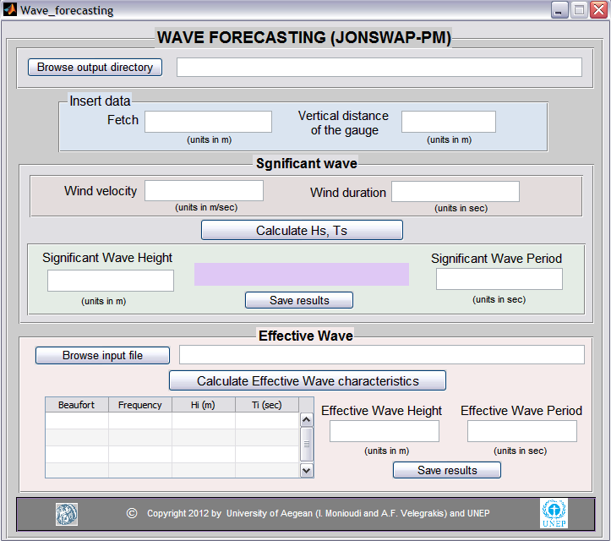
Fig. 3.1 The Toolbox GUI for wave estimation .

In the panel named ‘Insert data’ (Fig. 3.1), users enter information on the wind fetch and the z elevation of the wind gauge above sea level. User scan then calculate significant and effective wave characteristics.
In order to calculate significant waves, information on the wind velocity measured at z distance from the wind blow and the wind duration is required (Fig. 3.2). Once the required l parameters are entered, users can calculate significant wave height and period using the button ‘Calculate Hs, Ts’; the results appear in the edit boxes ‘Significant wave height’ and ‘Significant wave period’ (Figs 3.1 and 3.2). The type of wind wave growth is also provided in the text field below the edit boxes (Fig. 3.2).

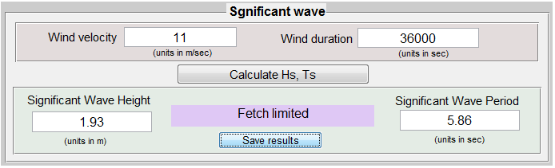
Fig. 3.2 Example of the significant wave procedure results.
Users can save the results by pushing the button ‘Save results’; a new window opens where users can give the filename of saved results (Fig. 3.3). The input and output values are saved as an excel file (Table 3.1) in the output directory given by the user.

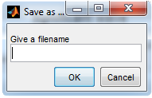
Fig. 3.3 The window that opens in order to provide the name of the file that will contain the results.

Table 3.1. Example of the output file with the resulted characteristics of significant wave.
INPUTS
Fetch (m) |  |  |  |  | 90000
Vertical distance of the gauge (m) |  |  |  |  | 15
Wind velocity (m/sec) |  |  |  |  | 11
Wind duration (sec) |  |  |  |  | 36000
RESULTS
Significant wave height (m) |  |  |  |  | 1,93
Significant wave period (sec) |  |  |  |  | 5,86
Situation of the sea |  |  |  |  | Fetch limited

In order to calculate effective waves, users should also browse for a .txt file (by pushing the button "Browse input file" in the panel "Effective wave") that will include information on he wind frequency (2nd column), the mean wind velocity (3rd column) and the wind duration (4th column) per Beaufort (1st column). This is the format of files obtained through the Wind data analysis GUI (see Fig. 2.3 and Section 2.2). Then effective wave characteristics can be calculated through the button "Calculate Effective Wave Characteristics". The results appear in the related edit boxes ‘Effective Wave Height’ and ‘Effective Wave Period’ and the table next to them is filed by the frequency, the wave height and period per Beaufort category resulted by the application of JONSWAP P-M method for every Beaufort class (Fig. 3.4). The table and the effective wave characteristics can be saved as an excel file by pushing the button "Save results", inside the panel "Effective Wave" (Fig. 3.1 and 3.4).

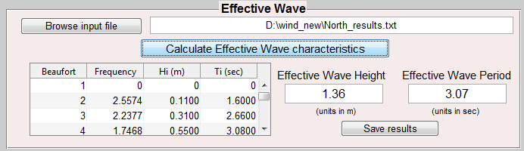
Fig. 3.4 Example of effective wave results.
4 Beach Retreat Estimator 2-Static/Analytical models GUI Manual
4.1 Introduction
Users can estimate beach retreat according to the static/analytical models of Bruun (1962; 1983; 1988) Edelman (1972) and Dean (1991) for the environmental conditions (beach slopes or bathymetries, wave heights and periods) and sea level rise scenarios of their interest. Users can select all, or some, of these models to create an ensemble and then obtain the mean values (by selected models) of beach retreat and the polynomial expression that fits in the projected mean retreat values. Beach Rtereat Estimator 2 consists of two GUIs: a linear beach profile GUI (exe file BRE_2a; and a natural profile GUI (exe file BRE_2b). For details of the 3 models, see the accompanying document Formation Zones d’ Erosion.

4.2 How to use the program
Following the installation of the MCR, the two platforms run by double-clicking on either the BRE_2a.exe (for linear profiles, Fig. 4.1) or the BRE_2b.exe (for natural profiles, Fig. 4.2). Both might take some time to open.
In the former GUI platform (BRE2, linear profiles), users may enter information on beach slope, wave height and wave period through the panel ‘Insert data’ (Fig. 4.1). They can also insert sea level rise scenarios using the button ‘Insert sea level rise scenarios’; an input dialog box appears with default values (Fig. 4.3) been already inserted which users may use, or users can erase these sea level rise levels and enter new values.

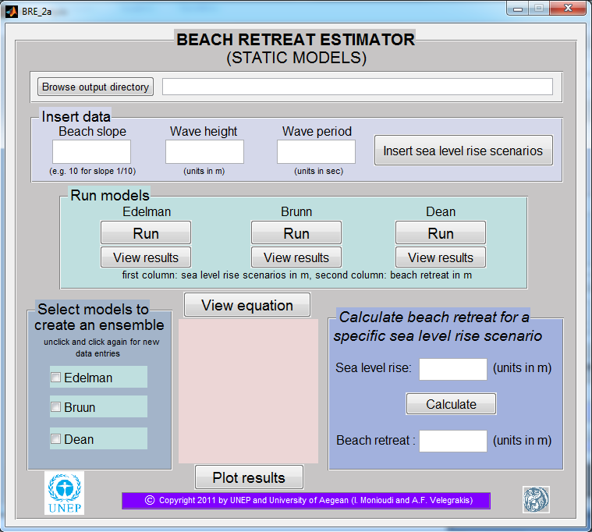
Fig. 4.1 The BRE_2a GUI (for linear profiles).

In the BRE_2b GUI platform (natural profiles, Fig. 4.2), users can use the ‘Browse…’ button (instead of the ‘Beach slope’ button of platform the BRE_2a, Fig. 1) to insert natural profile data.. The ‘Browse…’ button opens a new window through which users can search in their files for the desired .txt profile file, which must have the following format: they should two columns, the first column containing the cross-shore distance from the beginning of the profile (in meters) and the second corresponding elevation (also in meters). Such files can be obtained by e.g. using the EOF GUI (mean_profile1, see Section 1.3).

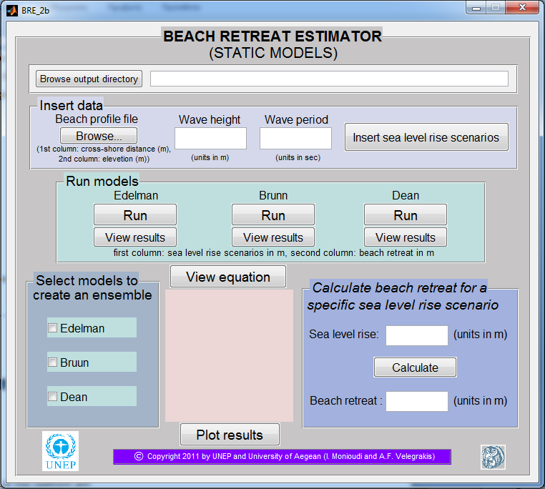
Fig. 4 2 The BRE_2b GUI (for natural profiles).

Once all parameters are entered, users can run the models using the buttons ‘Run’ inside the panel named ‘Run models’ (Figs 4.1, 4.2). Users have the option to view beach retreat estimations made by each model individually by pushing the button ‘View results’ below the pushbutton ‘Run’. When the ‘View results’ button is pressed, a message box opens with a table consisting of 2 columns. The first column is the sea level rise scenarios (in m) and the second is the model beach retreat estimations (in m). An example of this message box is shown as Figure 4.4. Users can also select models to create ensembles, by clicking in the corresponding checkboxes (Fig. 4.5).

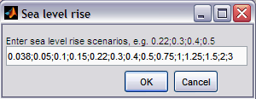
Fig.4.3 Input dialog box with default sea level rise scenarios.

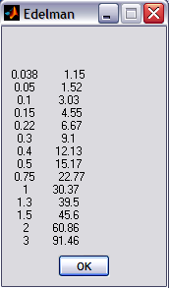
Figure 4.4 An example of message box with results of the Edelman model.

Once the models comprising the ensemble are selected, users may use the pushbutton ‘View equation’; then, a polynomial expression that better describes the ‘mean’ of the beach retreat estimations by the selected model ensemble appears in the text fields below the pushbutton (an example is shown as Fig. 4.5). This equations have the form: s = p₁a² +p₂a +p₃, where s: is the beach retreat, p₁, p₂ and p_{3:} are the polynomial coefficients and a: is the selected sea level rise. The value of R² is also given in the text field.

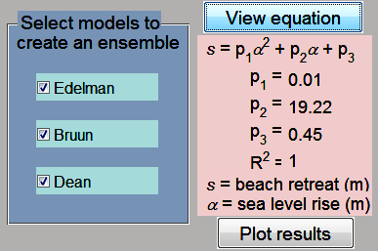
Fig. 4.5 An example of the estimated polynomial expression.

Pressing the pushbutton ‘Plot results’, the polynomial equations of selected models are calculated and plotted; the polynomial equation that fits the ‘mean’ (of all models) value of beach retreat is also plotted together with the projections by indivucal models. An example of such a plot is given as Fig. 4.6.

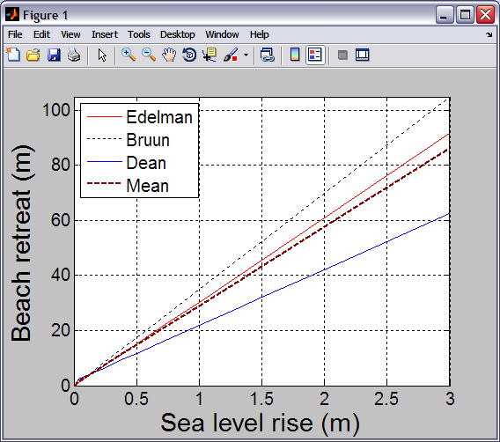

Fig. 4.6 An example of a result plot that contains the results by all three (3) models together with the ‘mean’ projection (stippled line) by all models for the set environmental conditions .

From the equation provided by the program, the range of beach retreat due to a specific sea level rise can be calculated. This program gives users the option to calculate the range of retreat only with a click on the pushbutton Calculate inside the panel ‘Calculate the retreat for a specific sea level rise scenario’. (Fig. 4.1. 4.2 and 4.7) An example is given in Figure 7.

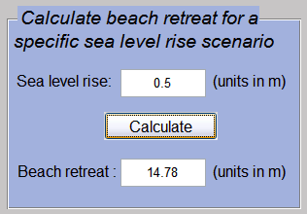
Fig.4.7 An example of beach retreat calculation for a specific sea level rise scenario.

4.3 Output files of the platforms
Output files are saved in the same folder with the platform’s exe file, replacing pre-existing files. These output files are:
extpr.txt (only for natural profiles): is the extended profile of the initial profile given by the user. First column represents the cross-shore distance (in m) and second column the elevation (in m).
sEdel.txt: is a 1 column matrix with beach retreat projections made by the Edelman (1972) model.
sBruun.txt: is a 1-column matrix with beach retreat projections made by the Bruun (1988) model.
sDean.txt: is a 1 column matrix with beach retreat projections made by the Dean (1991) model.
slrs.txt: is a 1 column matrix that contains the sea level scenarios entered by the user.
total_table.txt: is a table with 5 rows and columns equal to the number of the sea level rise scenarios entered by the user. It contains the beach retreat projections made by Edelman (1st row), Bruun (2nd row) and Dean (3rd row) models. Each column corresponds to a different sea level rise scenario.
path.txt: contains the path and the filename of the imported profile.
Beach retreat estimations.tiff: is the plot of the polynomial equations of all selected models together with the polynomial equation that fits in the mean values of the selected models of beach retreat projections under different sea levels.
5 Beach Retreat Estimator 3-Dynamic models GUI Manual
5.1 Introduction
Users of this GUI can estimate beach retreat according to dynamic models (Leont’yev and SBEACH) for particular environmental conditions (beach slope, wave height, wave period, sediment size) and sea level rise scenarios of their interest. The models should run first at the current sea level (no sea level rise scenario is considered). In this way the profile evolution caused only by the current environmental forcing is estimated. Then the resulting profile is used as an initial profile for the assessment of sea level rise effects. This GUI is consisted of the exe files BRE_3a (for linear profiles) and BRE_3b (for natural profiles).

5.2 How to use the program
Following the installation of the MCR, the two platforms run by double-clicking on either the BRE_3a.exe (for linear profiles, Fig. 5.1) or the BRE_3b.exe (for natural profiles, Fig. 5.2). Both might take some time to open. The following exe files (compiled in FORTRAN) must be in the same folder with the GUI exe file.
leo_first run: Leont’yev run without sea level rise
leo_slr run: Leont’yev run with sea level rise
sbeach_first run: SBEACH run without sea level rise
sbeach_slr run: SBEACH run with sea level rise.

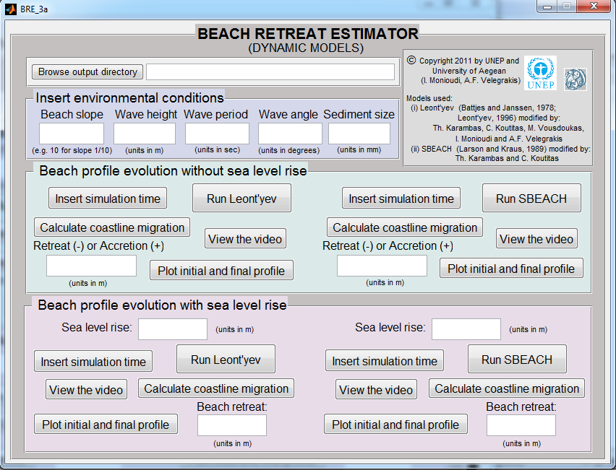
Fig. 5.1 The BRE_3a GUI (for linear profiles).

In the panel named ‘Insert environmental conditions’, the user enters information on beach slope, wave height, wave period, wave angle and sediment size (Fig. 5.1). In the BRE_3b platform for natural profiles, there is a ‘Browse…’ button instead of the ‘Beach slope’ edit box (Fig. 5.2). The ‘Browse…’ pushbutton opens a new window through which users can search in their files for the .txt profile file. This file should have two columns, the first column referring to the cross-shore distance in meters and the second to the elevation also in meters. Such a file might be obtained by the EOF platform.

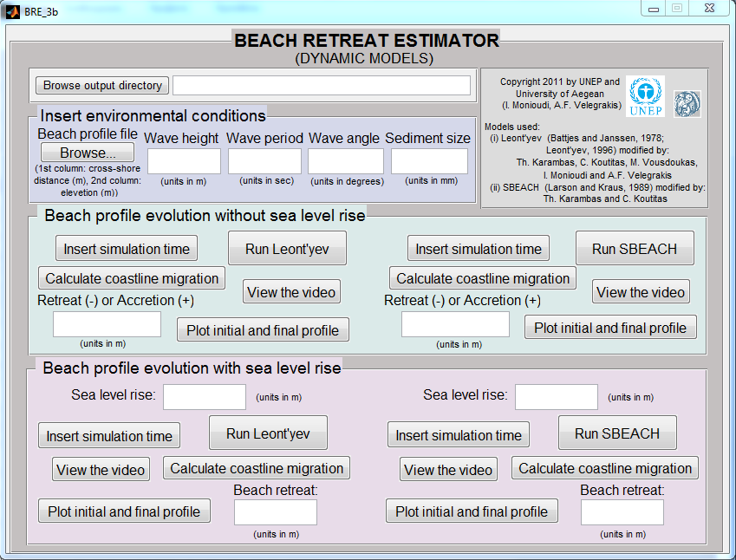
Fig. 5.2 The BRE_3b GUI (for natural profiles).

Once all parameters are determined, users can enter the simulation time of their preference using the pushbutton ‘Insert simulation time’, then they can run the models by using the pushbuttons ‘Run Leont’yev’ or ‘Run SBEACH’ inside the panel named ‘Beach profile evolution without sea level rise’ (Figs 5.1 and 5.2). A waitbar appears with the title ‘Please wait...’ (Fig. 5.3). Users should wait (or they can cancel the process by using the pushbutton "cancel" inside the waitbar window) for the process to be completed, then a message informs the user if the model has ran successfully. During the process, instability of the model may cause the process to stop; then a warning message appears, informing users that the model stopped running and how many calculations have been completed successfully. Users can calculate coastline migration (Retreat (-) or Accretion (+)) by using the pushbutton ‘Calculate coastline migration’; then the result appears in the edit box ‘Retreat (-) or Accretion (+)’. Users have also the options to view the video of the profile evolution and to plot the initial and final profile (Fig. 5.4) by using the pushbutton ‘View the video’ and ‘Plot initial and final profile’, respectively.

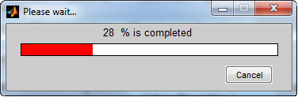
Fig. 5.3 The waitbar that appears during the model’s run.

Once the resulted profile by the environmental forcing is estimated, sea level rise effects can be also assessed. Users can enter the sea level rise scenario of their interest (in the edit box ‘Sea level rise’), the desired simulation time (by using the pushbutton ‘Insert simulation time’) and then they can run the models by using the pushbuttons ‘Run Leont’yev’ or ‘Run SBEACH’ inside the panel named ‘Beach profile evolution with sea level rise’ (Figs 5.1 and 5.2).

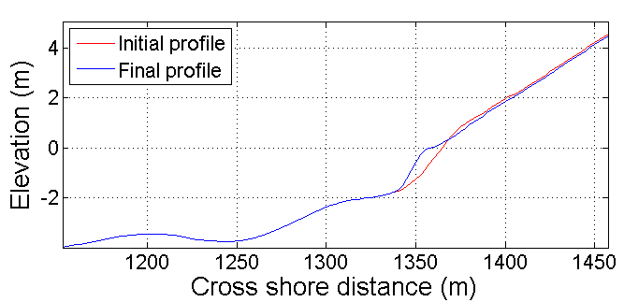
Fig. 5.4 An example of initial and final profile plotting.

Once the model process has been completed successfully, users have the options to calculate the retreat of the coastline, to view the video of profile evolution and to plot initial and final profiles by using the pushbuttons ‘Calculate coastline migration’, ‘View the video’ and ‘Plot initial and final profile’ respectively (Figs 5.4 and 5.5).

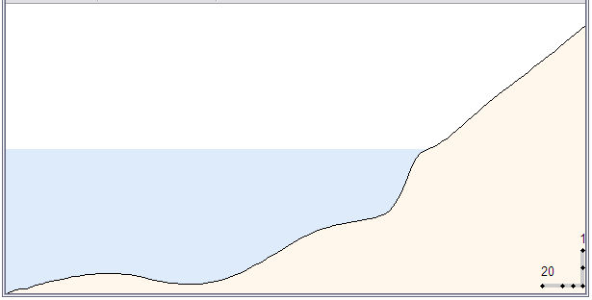
Fig. 5.5. An example frame of profile evolution video.

5.3 Output files

extpr.txt (only for natural profiles): is the extended profile of the initial profile given by the user. First column is cross-shore distance (in m) and second column is elevation (in m).

Output files from Leont’yev runs without sea level rise:
inputs_leo_fr.txt: file with user’s input data e.g. [10 2 6 0.8 220 45]
where 10 the beach slope (for natural profiles, beach slope is estimated by the mean slope of the swash zone), 2 wave height (in m), 6 wave period (sec), 0.8 grain size (in mm) 220 the number of beach profile points defined by the bed slope (if the profile starts at 20 m water depth and reaches to 10 m elevation above the sea level) and 45 is the wave angle.
in_bathy_leo.txt: the initial profile.
time_leo_fr.txt: simulation time set by the user.
bed_leo_fr.txt: the final model output with the first column showing the x axis, the second column the final profile and the third the profile of the previous run.
all_bathy_leo_fr.txt: each column contains the topographic elevation after each iteration. For example, for time 40 (40*200=8000sec) the file contains 40 columns.
situation_leo_fr.txt: the file contains information on the condition of the run. For example, the first value shows if the model ran correctly (value 0) or stopped (value 1). The second value shows if the model gives NaN values for the profile, the 3rd value shows if the model gives zero values for the profile, the 4th value shows if the model gives ****** values for the profile and the 5th value shows the iteration that showed instability and stopped. If the model run successfully to the end for e.g. the default (40) time then the values will be:
0
0
0
0
40

If the 20^{η} time the model stopped and gave NaN values, then ‘Warning’ appears (‘The model stopped running, it have run 19 times’) and the values on the table will be:
1
1
0
0
20
Leont_fr.tiff: figure file with the initial and final profile
leont_fr.avi: video file.

Output files from Leont’yev runs with sea level rise:
inputs_leo_slr.txt: file with user’s input data e.g. [10 2 6 0.8 220 45] where 10 the beach slope (for natural profiles, beach slope is estimated by the mean slope of the swash zone), 2 wave height (in m), 6 wave period (sec), 0.8 grain size (in mm) 220 the number of beach profile points defined by the bed slope (if the profile starts at 20 m water depth and reaches to 10 m elevation above the sea level) and 45 is the wave angle.
slr_scenario_leo.txt: file containing one value (user input for sea level rise).
time_leo_slr.txt: simulation time set by the user.
bed_leo_slr.txt: the final model output with the first column showing the x axis, the second column the final profile and the third the profile of the previous run.
all_bathy_leo_slr.txt: each column contains the topographic elevation after each iteration. For example, for time 40(40*200=8000sec) the file contains 40 columns.
situation_leo_slr.txt: the file contains information on the condition of the run. For example, the first value shows if the model ran correctly (value 0) or stopped (value 1). The second value shows if the model gives NaN values for the profile, the 3rd value shows if the model gives zero values for the profile, the 4th value shows if the model gives ****** values for the profile and the 5th value shows the iteration that showed instability and stopped. If the model run successfully to the end for e.g. the default (40) time then the values will be:
0
0
0
0
40
If the 20^{η} time the model stopped and gave NaN values, then ‘Warning’ appears (‘The model stopped running, it have run 19 times’) and the values on the table will be:
1
1
0
0
20

Leont_slr.tiff: figure file with the initial and final profile
leont_slr.avi: video file.

Output files from SBEACH runs without sea level rise:
inputs_SB_fr.txt: file with user’s input data e.g. [10 2 6 0.8 220 45], where 10 the beach slope (for natural profiles, beach slope is estimated by the mean slope of the swash zone), 2 wave height (in m), 6 wave period (sec), 0.8 grain size (in mm) 220 the number of beach profile points defined by the bed slope (if the profile starts at 20 m water depth and reaches to 10 m elevation above the sea level) and 45 is the wave angle.
in_bathy_SB.txt: the initial profile.
time_SB_fr.txt: simulation time set by the user.
bed_SB_fr.txt: the final model output with the first column showing the x axis, the second column the final profile and the third the profile of the previous run.
all_bathy_SB_fr.txt: each column contains the topographic elevation after each iteration For example, for time 40(40*200=8000sec) the file contains 40 columns.
situation_SB_fr.txt: the file contains information on the condition of the run. For example, the first value shows if the model ran correctly (value 0) or stopped (value 1). The second value shows if the model gives NaN values for the profile, the 3rd value shows if the model gives zero values for the profile, the 4th value shows if the model gives ****** values for the profile and the 5th value shows the iteration that showed instability and stopped. If the model run successfully to the end for e.g. the default (40) time then the values will be:
0
0
0
0
40
If the 20^{η} time the model stopped and gave NaN values, then ‘Warning’ appears (‘The model stopped running, it have run 19 times’) and the values on the table will be:
1
1
0
0
20

SBEACH_fr.tiff: figure file with the initial and final profile
sbeach_fr.avi: video file.

Output files from SBEACH runs with sea level rise:
inputs_SB_slr.txt: file with user’s input data e.g. [10 2 6 0.8 220 45] where 10 the beach slope (for natural profiles, beach slope is estimated by the mean slope of the swash zone), 2 wave height (in m), 6 wave period (sec), 0.8 grain size (in mm) 220 the number of beach profile points defined by the bed slope (if the profile starts at 20 m water depth and reaches to 10 m elevation above the sea level) and 45 is the wave angle.
slr_scenario_SB.txt: file containing one value (user input for sea level rise).
time_SB_slr.txt: simulation time set by the user.
bed_SB_slr.txt: the final model output with the first column showing the x axis, the second column the final profile and the third the profile of the previous run.
all_bathy_SB_slr.txt: each column contains the topographic elevation after each iteration. For example, for time 40(40*200=8000sec) the file contains 40 columns
situation_SB_slr.txt: the file contains information on the condition of the run. For example, the first value shows if the model ran correctly (value 0) or stopped (value 1). The second value shows if the model gives NaN values for the profile, the 3rd value shows if the model gives zero values for the profile , the 4th value shows if the model gives ****** values for the profile and the 5th value shows the iteration that showed instability and stopped. If the model run successfully to the end for e.g. the default (40) time then the values will be:
0
0
0
0
40
If the 20^{η} time the model stopped and gave NaN values, then ‘Warning’ appears (‘The model stopped running, it have run 19 times’) and the values on the table will be:
1
1
0
0
20

SBEACH_slr.tiff: figure file with the initial and final profile
sbeach_slr.avi: video file

References
Aubrey, D. G., 1979, Seasonal patterns of onshore/offshore sediment movement, Journal of Geophysical Research 84, 6347-6354.
Borah D.K. and Balloffet A., 1985, Beach evolution caused by littoral drift barrier, J. of Waterway, Port, Coastal and Ocean Eng., ASCE, 111(4): 645-660.
Bruun, P., 1962, Sea level rise as a cause of shore erosion, Journal of Waterway, Harbors Division. ASCE 88, 117-130.
Bruun, P., 1983, Review of conditions for uses of the Bruun rule of erosion, Coastal Engineering 7(1), 77-89.
Bruun, P., 1988, The Bruun Rule of erosion by sea level rise: A discussion on large-scale two- and three-dimensional usages, Journal of Coastal Research 4(4), 622-648.
Dean, R. G., 1991, Equilibrium beach profiles: characteristics and applications, J. Coastal Research 7(1), 53– 84.
Edelman, T., 1972, Dune erosion during storm conditions, in: Proceedings of the 13th International Conference on Coastal Engineering ASCE, pp. 1305-1312.
Hasselmann, K., Ross, D.B., Muller, P., Sell, W., 1976, A Parametric Wave Prediction Model, Journal of Physical Oceanography 6, pp. 200-228.
Komar, P. D., 1998, Beach Processes and Sedimentation, Prentice Hall, N.J., USA, pp. 544.
Koutitas, X.G., 1994. Introduction to coastal engineering and port works. Ziti Publication, Thessaloniki, Greece. (in Greek).
Larson, M., and Kraus, N. C., 1989, SBEACH: numerical model for simulating storm-induced beach change; report 1: empirical foundation and model development, Technical Report - US Army Coastal Engineering Research Center 89-9.
Leont'yev, I. O., 1996, Numerical modelling of beach erosion during storm event, Coastal Engineering 29(1-2),187-200.
Leont'yev, I. O., 1997, Short-term shoreline changes due to cross-shore structures: a one-line numerical model, Coastal Engineering 31(1-4), 59-75.
Winant, C. D., Inman, D.L., and Nordstron, C.E., 1975, Description of Seasonal Beach Changes Using Empirical Eigenfunctions, Geophysical Research 80(15), 1979-1986.

In the long-shore direction, interpolation is necessary for the application of EOF analysis

