SINGLE-CELL TRANSCRIPTOME AND EPIGENETIC PROFILING OF THE PITUITARY GLAND PROVIDES INSIGHTS INTO TELEOST PUBERTY

Colonna, L. ¹, Konstantinidis, I. ¹, Daniels, R.R. ², Robledo, D. ² and Fernandes, J.M.O. ^{1,3}
¹Nord University (FBA), Bodø, Norway; ²The Roslin Institute, Edinburgh, Scotland, ³Institute of Marine Science (ICM), Barcelona, Spain.
e-mail: lorenzo.colonna@nord.no
The onset of puberty in farmed fish species brings about a set of phenotypic and behavioural changes that can negatively impact productivity and the environment. Although the onset of puberty can be controlled to some extent via photoperiod and temperature manipulation, in industrial-scale sea cages their application is limited. As puberty is largely affected by external stimuli, we hypothesize that transcriptional and epigenetic signals in key tissues, such as the pituitary gland, can shed light into the fundamental biological networks that regulate puberty. Thus, we performed a pilot study using Nile tilapia (Oreochromis niloticus) as a model organism for reproductive endocrinology. Fish were exposed to continuous or ambient light for 4 months and their morphometric characteristics were recorded. To capture the in-depth biological mechanisms that underlie puberty, we used state-of-the-art single-cell multiome (RNAseq and ATACseq) profiling. We identified major cell types with distinct gene expression (Figure 1) and chromatin accessibility profiles. By performing differential expression (DE) and accessibility (DA) analysis, we were able to identify key cell types of the pituitary gland and biological markers that may play an important role in the onset of puberty in fish. These results will be utilized in project EPICOD for the optimization of single-cell analysis and cell-type annotation in Atlantic cod (Gadus morhua) and European seabass (Dicentrarchus labrax), and offer a baseline for interspecies comparisons among commercially valuable fish species.

Keywords: Single-cell, RNA-Seq, ATAC-Seq, Teleost, Puberty
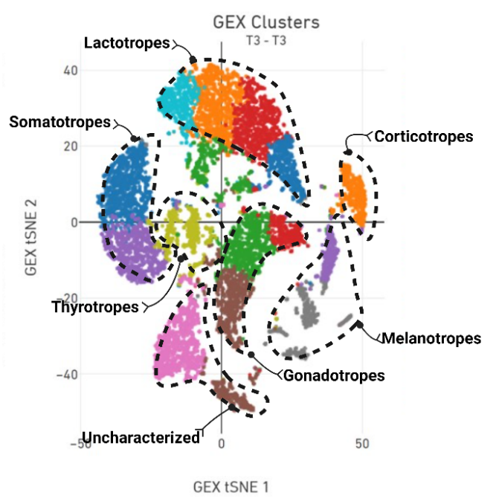

Figure 1. xxxxx

Figure 1. Clusters of pituitary cell types showing distinct gene expression profiles.

Reference
M. Li, L. Sun, L. Zhou & D. Wang (2024). Gen Comp Endocrinol 345:114395.

